Madison Fire Protection District
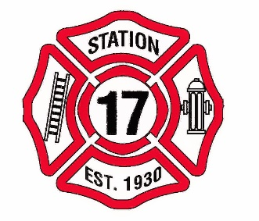
Commissioners Meeting
17880 Stephens St.
November 12, 2018
1:00 p.m.

1. Meeting called to order. Roll Call.

2. Approval of the November 12, 2018 agenda.

3. Approval of minutes from October 8, 2018 meeting.

4. Public Comment- This is a time for the public to address the board on any subject related to the Madison Fire Protection District. The Board reserves the right to impose a reasonable limit of time afforded to any individual speaker.

5. Financial Report

6. Chief’s Report

7. Maintenance Report

8. Discussion Items

9. Action Items A. Approve authorized Commissioners to sign for purchase of property at
28864 Main St., Madison, Ca. Parcel Number 049-443-005-000

10. Approval of the claims for Payment

11. Future Agenda Items

12. General Discussion

13. Adjournment

I declare under penalty of perjury the forgoing agenda was posted on or before November 2, 2018 by 5:00 p.m. at the Madison Fire Station, 17880 Stephens St., Madison, Ca. 95653.
Secretary

If requested, the Madison Fire District will make this agenda available in appropriate formats to persons with a disability. Persons seeking an alternative form should contract Jody Green, secretary to the Madison Fire District Commissioners. In addition, a person with a disability who requires a modification or accommodations, including auxiliary aids or services, order to participate in a public meeting, should telephone or otherwise contract the secretary of the commissioners as soon as possible and preferably at least 24 hours prior to the meeting. The secretary may be reach at (530)662-5745 or (530) 666-6950.

17880 Stephens St. P. O. Box 12. Madison, Ca 95653
(530) 662-5745 Fax (530)662-3441

