Madison Fire Protection District
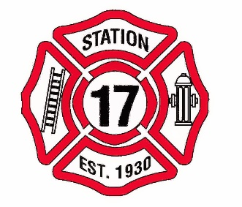
Commissioners Meeting
17880 Stephens St.

No Meeting on August 13, 2018

