Madison Fire Protection District
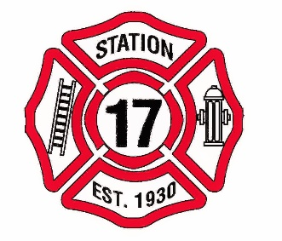
Commissioners Meeting
17880 Stephens St.
May 13, 2019
1:00 p.m.

1. Meeting called to order. Roll Call.

2. Approval of the May 13, 2019 agenda.

3. Approval of minutes from April 8, 2019 meeting.

4. Public Comment- This is a time for the public to address the board on any subject related to the Madison Fire Protection District. The Board reserves the right to impose a reasonable limit of time afforded to any individual speaker.

5. Financial Report

6. Chief’s Report

7. Maintenance Report

8. Action Items A. Letter to volunteers put on hold, Chief will discuss letter with volunteers. B. Revisit By-Laws, policy on meeting absence C. Resolution 19-01 Requesting Collection of Charges on Tax Roll

9. Approval of claims for payment.

10. Future Agenda Items

11. General Discussion

12. Adjournment

I declare under penalty of perjury the forgoing agenda was posted on or before May 8, 2019 by 5:00 p.m. at the Madison Fire Station, 17880 Stephens St., Madison, Ca. 95653.
Secretary

If requested, the Madison Fire District will make this agenda available in appropriate formats to persons with a disability. Persons seeking an alternative form should contract Jody Green, secretary to the Madison Fire District Commissioners. In addition, a person with a disability who requires a modification or accommodations, including auxiliary aids or services, order to participate in a public meeting, should telephone or otherwise contract the secretary of the commissioners as soon as possible and preferably at least 24 hours prior to the meeting. The secretary may be reach at (530)662-5745 or (530) 666-6950.

17880 Stephens St. P. O. Box 12. Madison, Ca 95653
(530) 662-5745 Fax (530)662-3441

